First doubt: ‘access VLAN does not exist. Creating vlan 20’ on a access switch

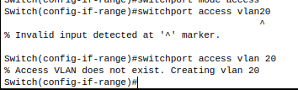

I thought the following message showed on the image above ‘Access VLAN does not exist. Creating vlan 20’ was an error but it is not.

The message is a normal process which happens on Switches when it is being assigned a VLAN to its ports. What is happening basically is the Switch database storing the new VLAN.

Second doubt: ‘switchport access vlan20
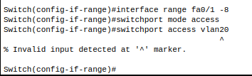

It was where the marker is on the image. At first I thought it was a huge error but it wasn't. I basically forgot to add space on the following command ‘switchport access vlan20’
I must have typed with space when assigning a number to a VLAN. The correct form would be:
- ‘switchport access vlan 20’ - notice the space between the key word ‘vlan’ and the number ‘20’.

Third doubt: ‘interface range not validated’
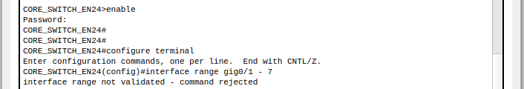
Similarly to the other errors it was basically a wrong configuration due to the device. Some devices only have two gigabit Ethernet ports, in this project I’m using a multilayer 3650-24PS which is the core switch of the project and I came across this error when I was setting the trunks.
I solved it by checking out the syntax of the ports then correcting it on the CLI and also looking for the number of gigabit Ethernet available on the device. Thereafter I ran the correct IOS command to execute the correct range of trunk ports.
And my ports are:
GigabitEthernet1/0/1
GigabitEthernet1/0/2
GigabitEthernet1/0/3
GigabitEthernet1/0/4
GigabitEthernet1/0/5
GigabitEthernet1/0/6
GigabitEthernet1/0/7
⚠️ Notice something VERY important:
My interfaces are:
GigabitEthernet1/0/X
NOT
GigabitEthernet0/X

